Sheridan Dela Cruz
April 30, 2026
Module 7.2

Output of city_functions.py
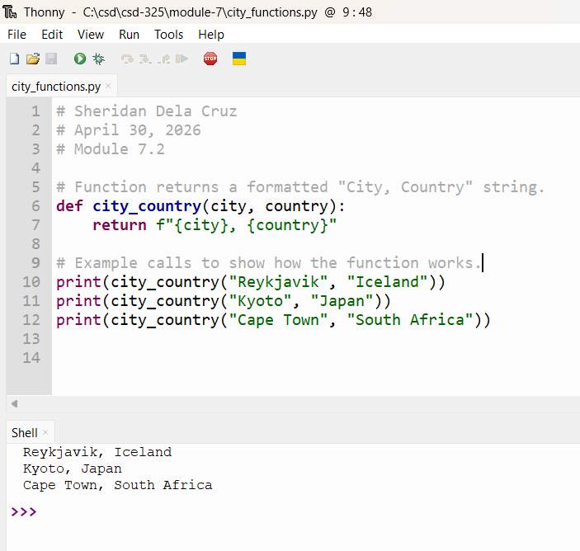

Passing Test
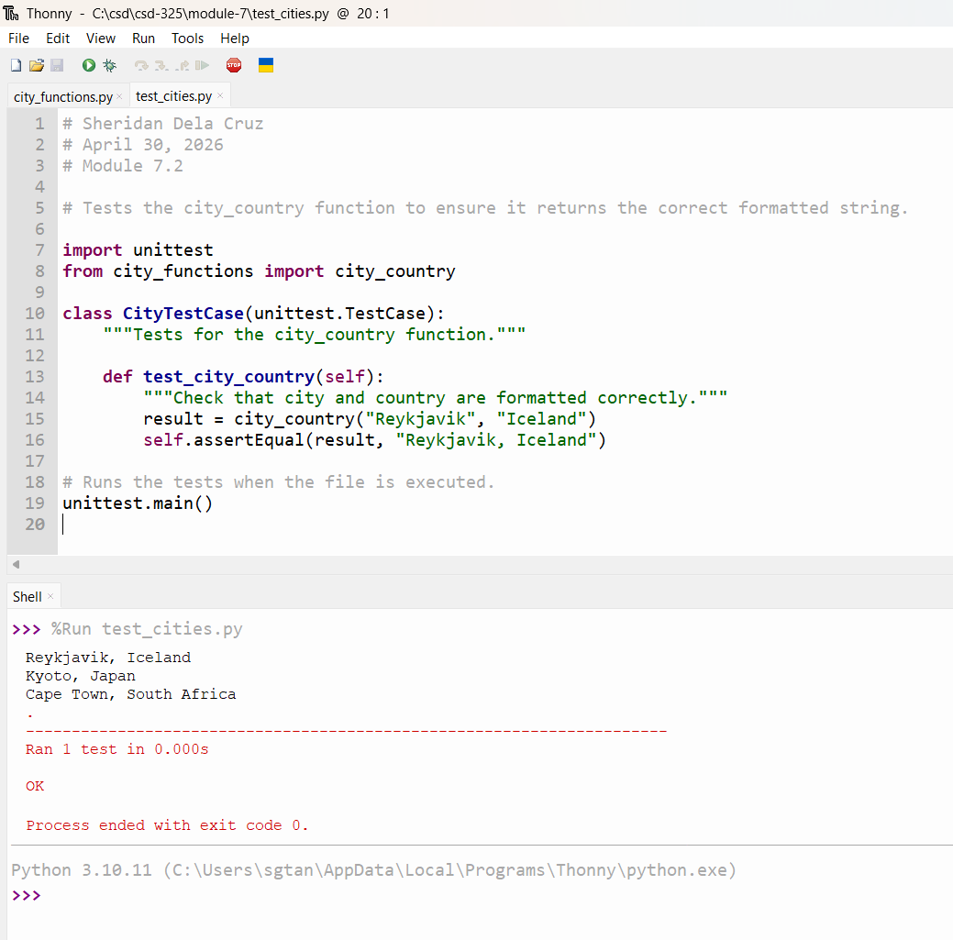

Failing Test After Adding Required Population
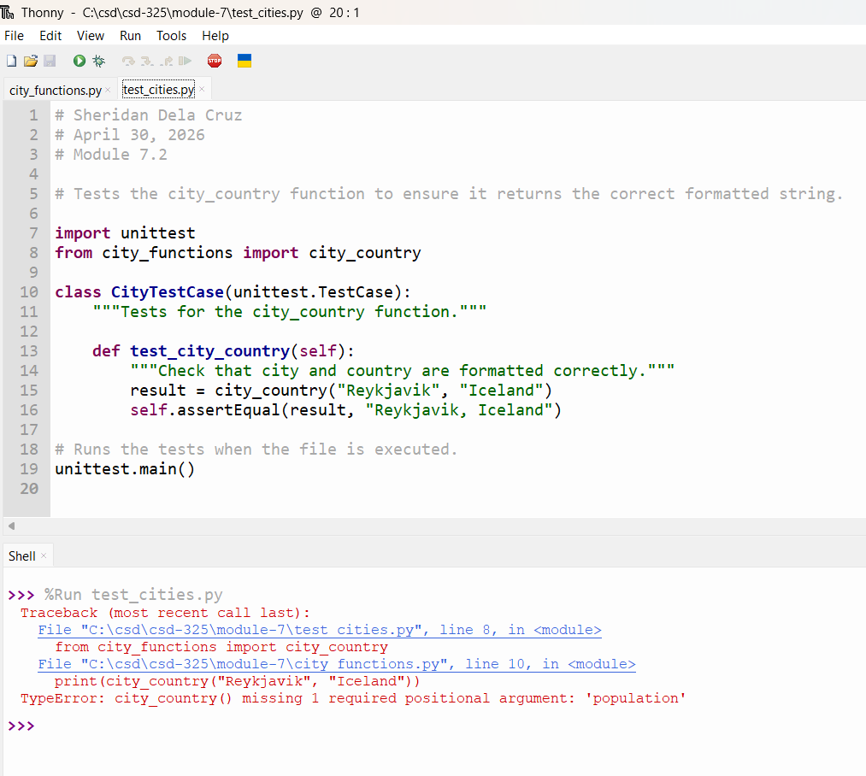

Passing Test After Making Population Optional
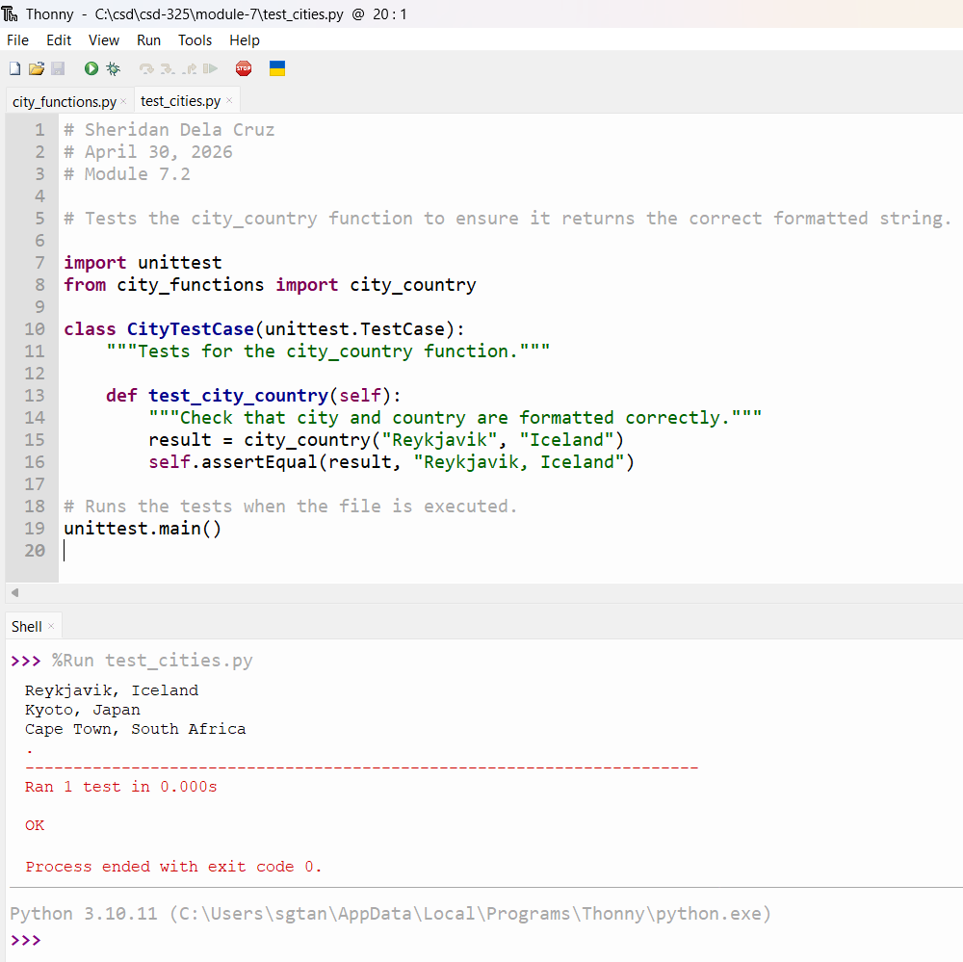

Failing Test After Adding Required Language
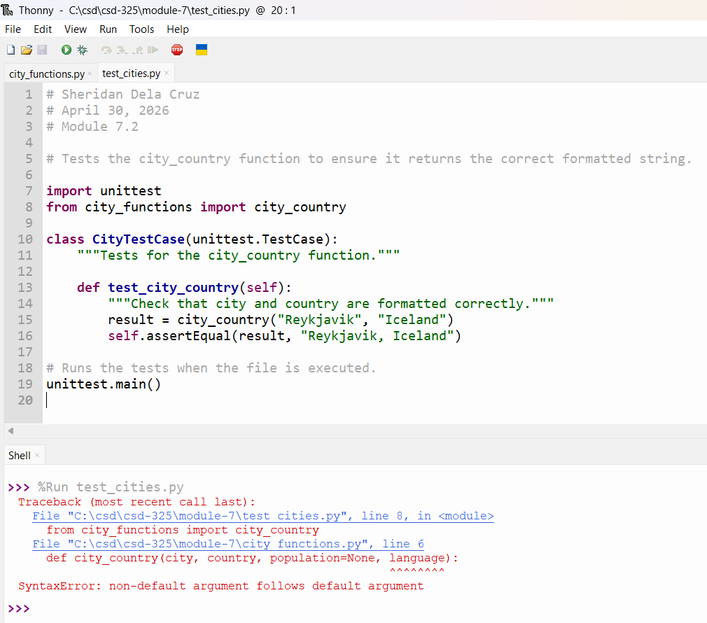

Passing Test After Making Language Optional
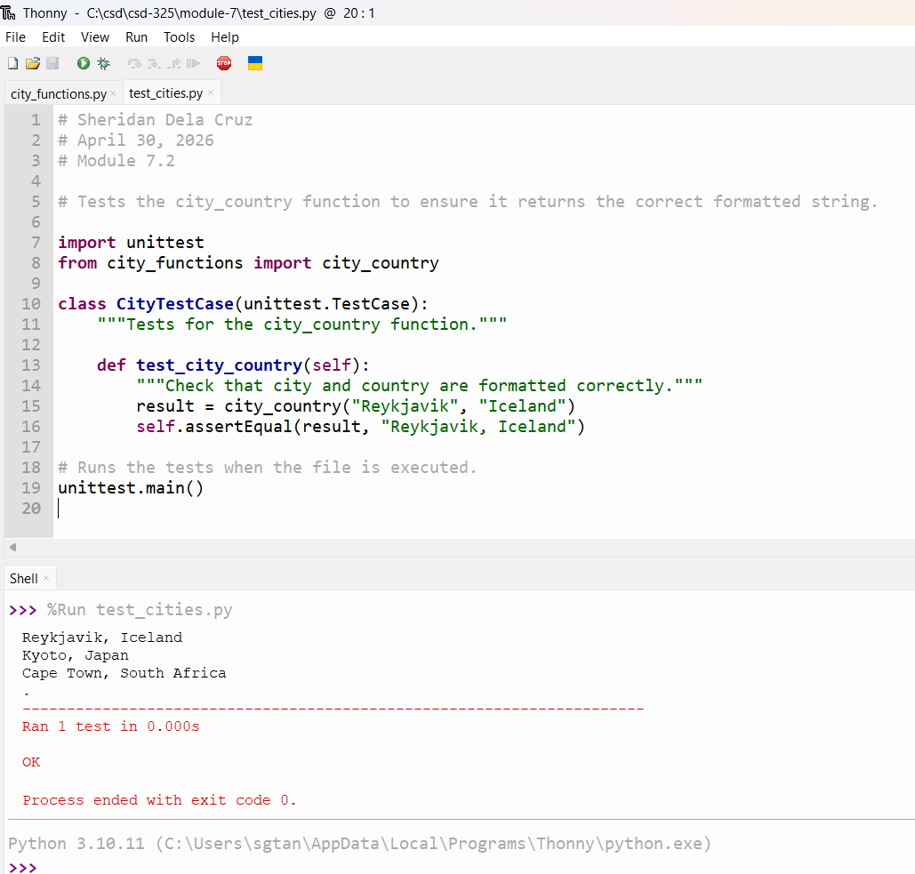

Final Output with New Cities
